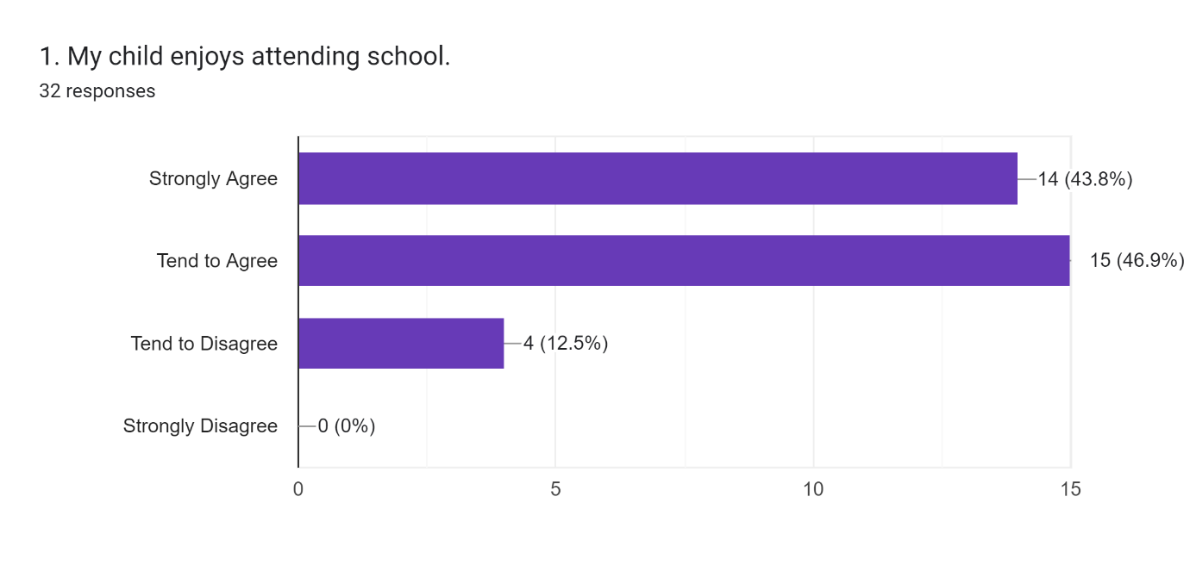
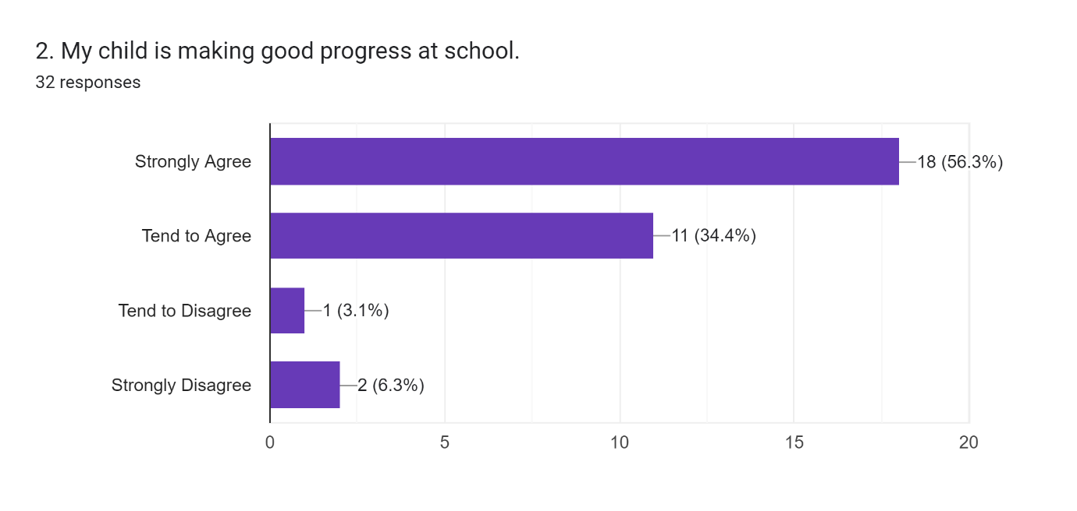
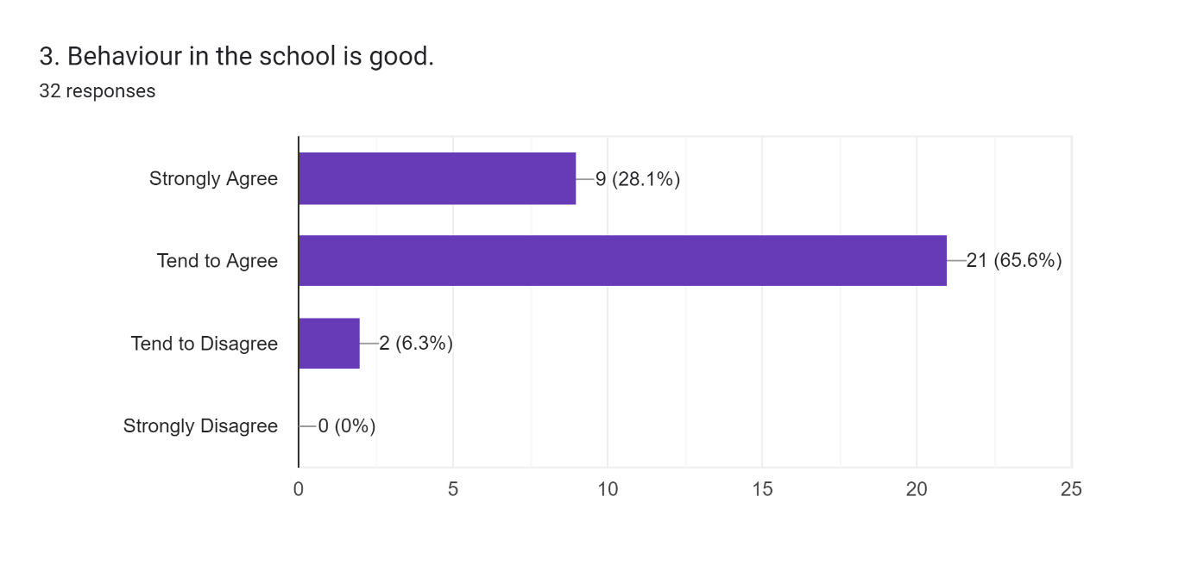

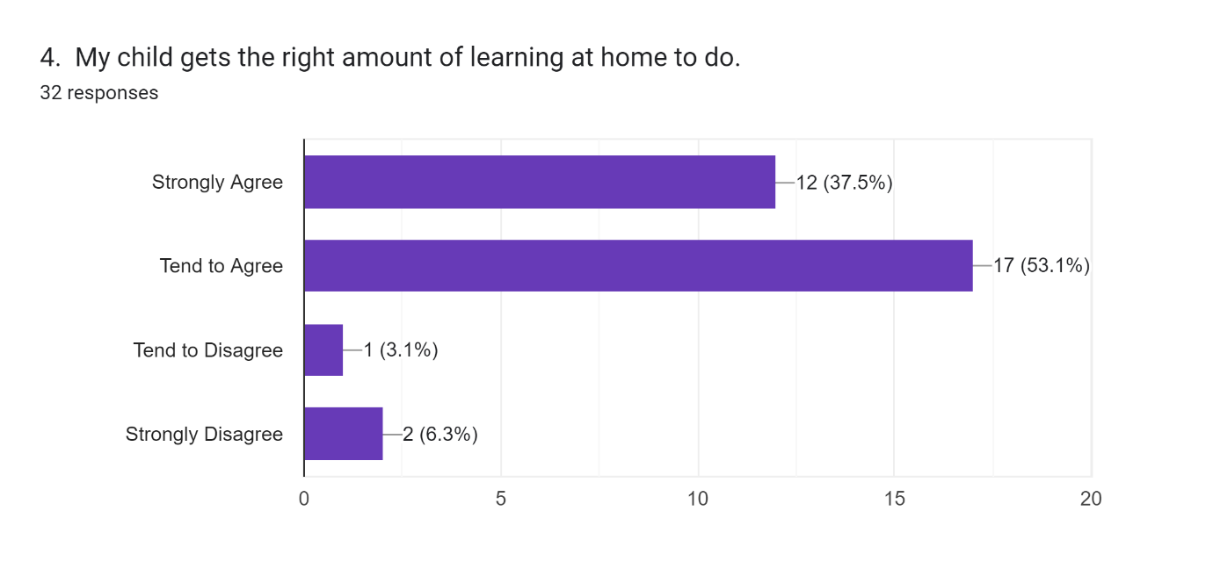
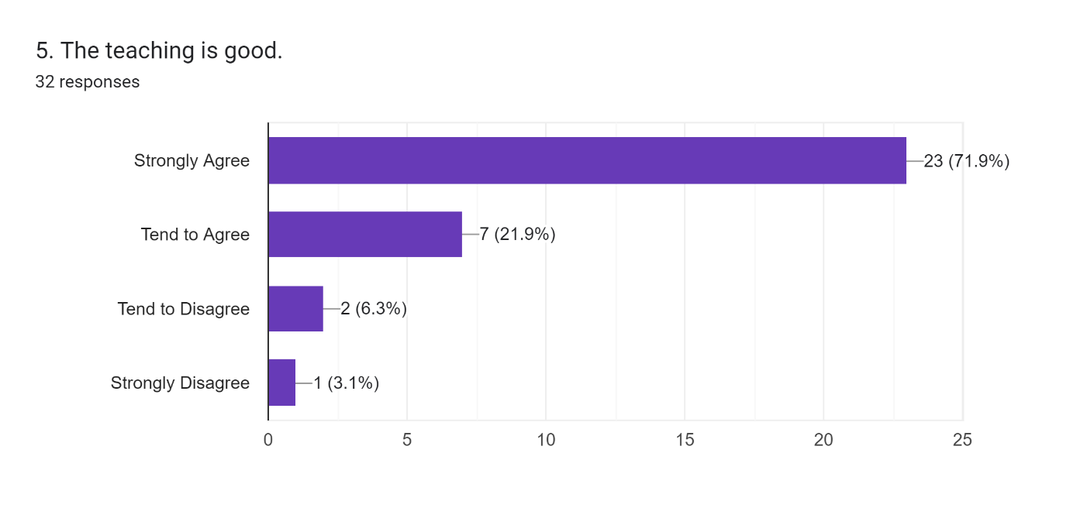
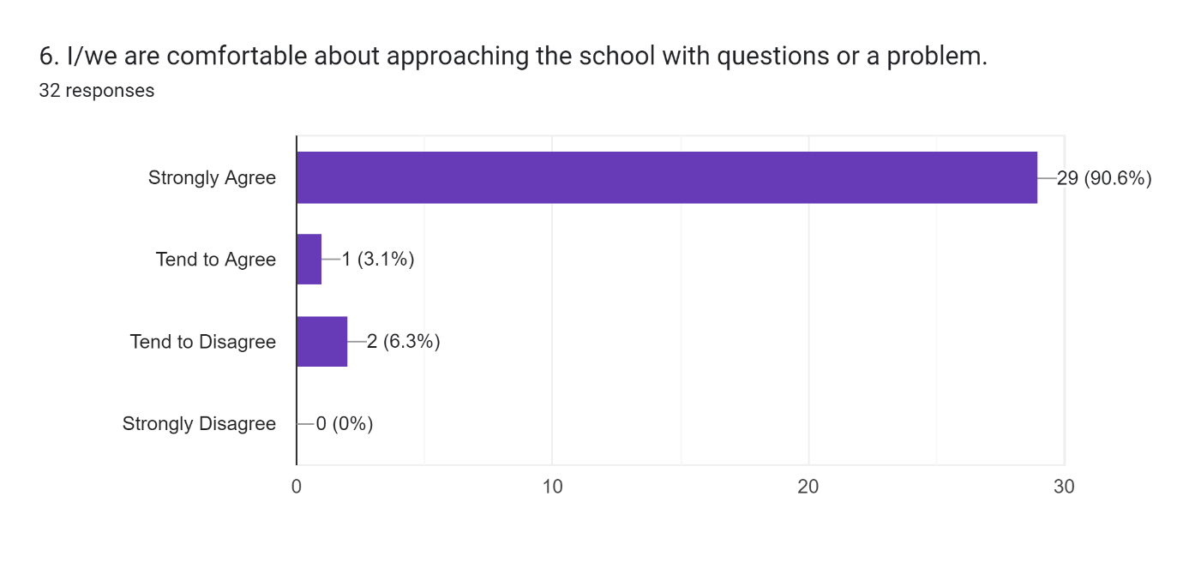
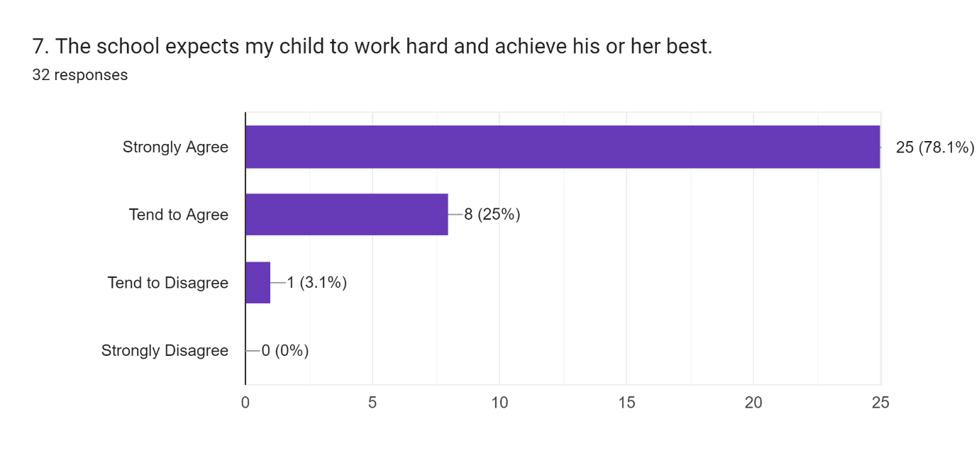
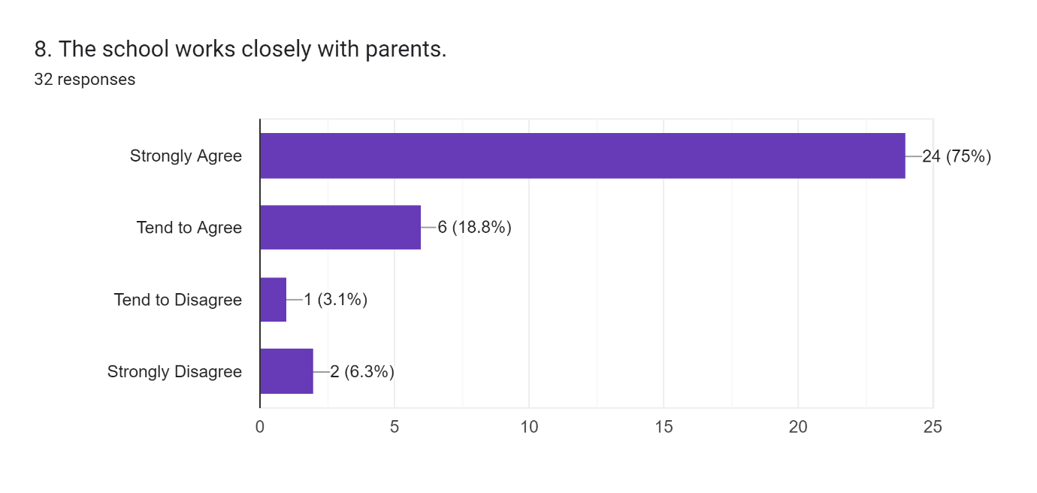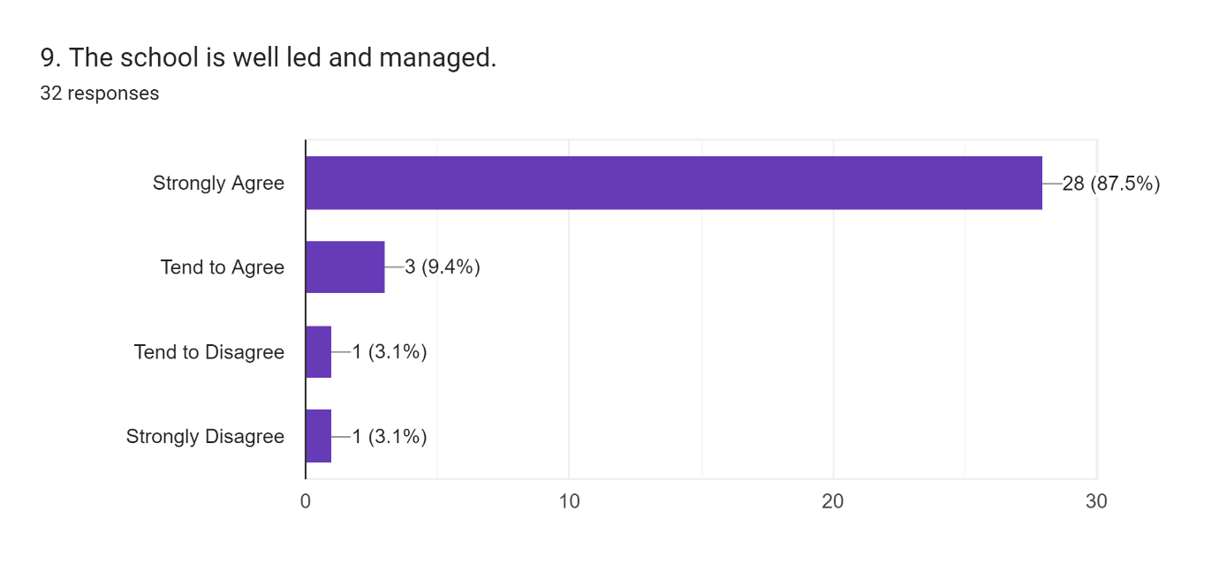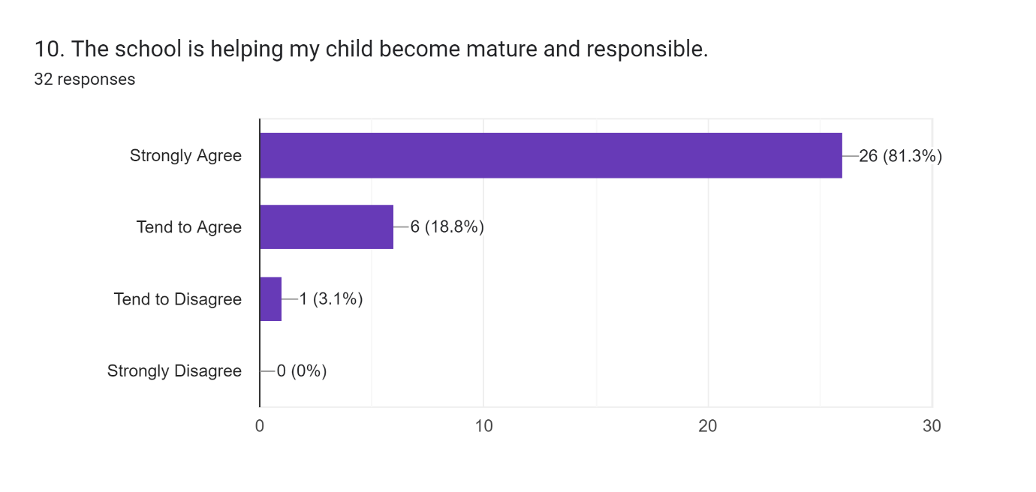
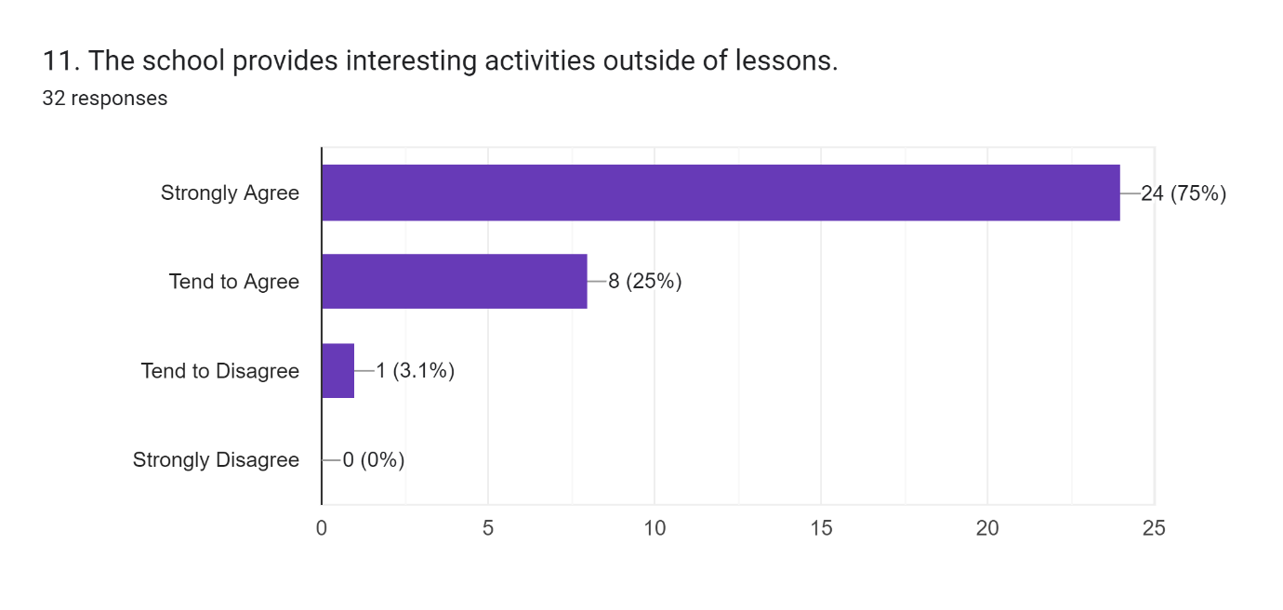
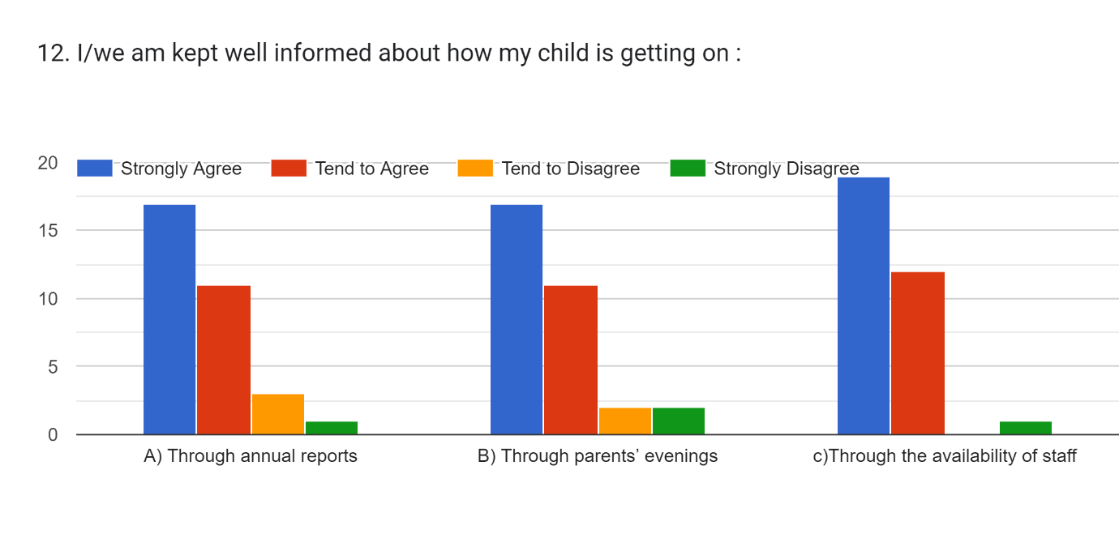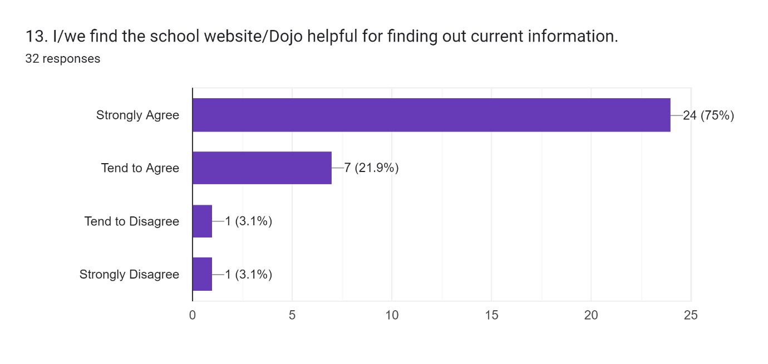
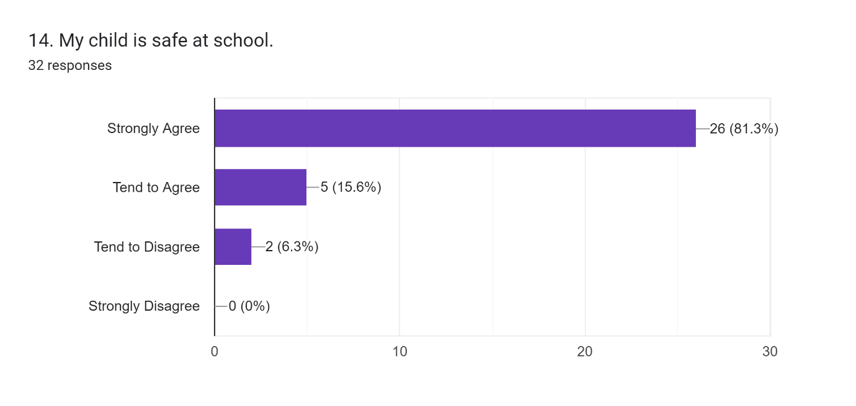 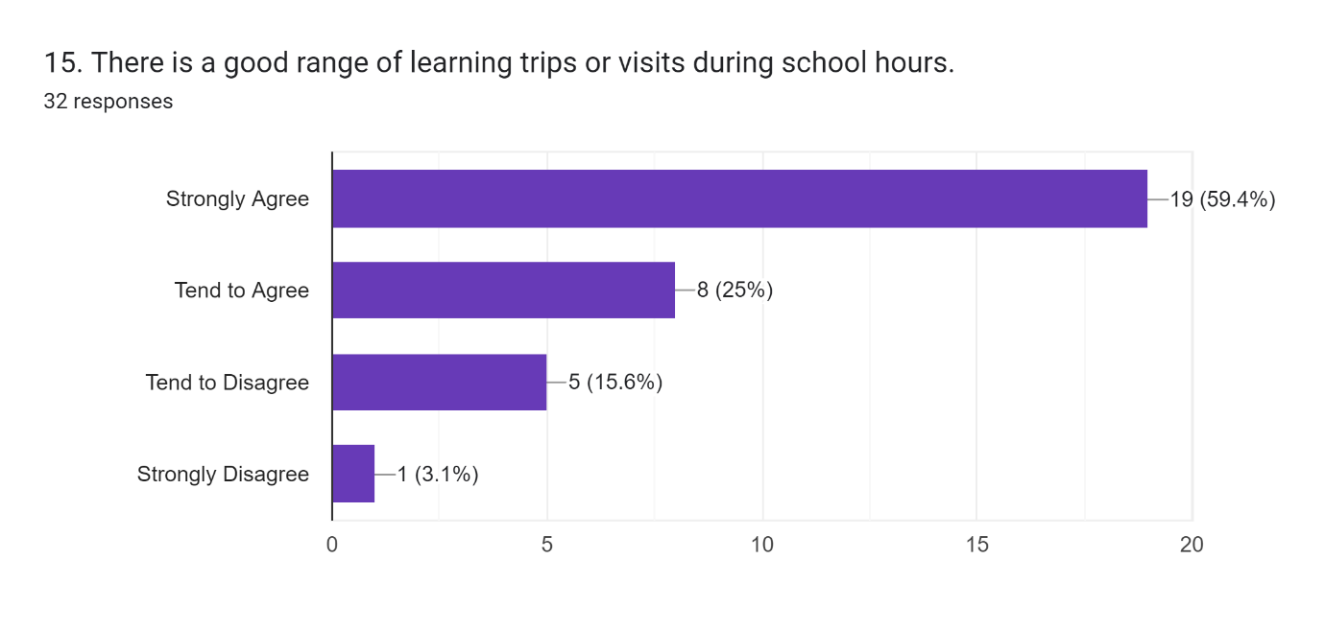 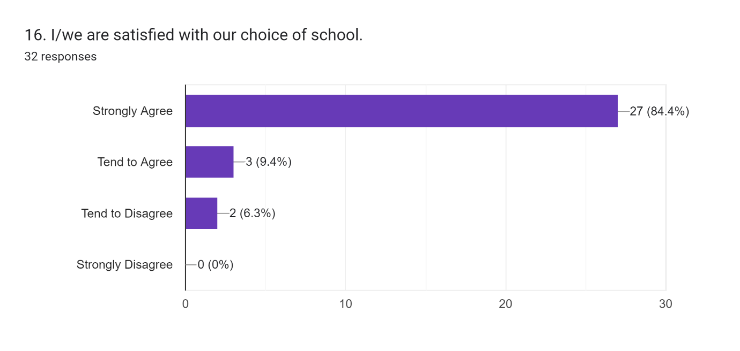 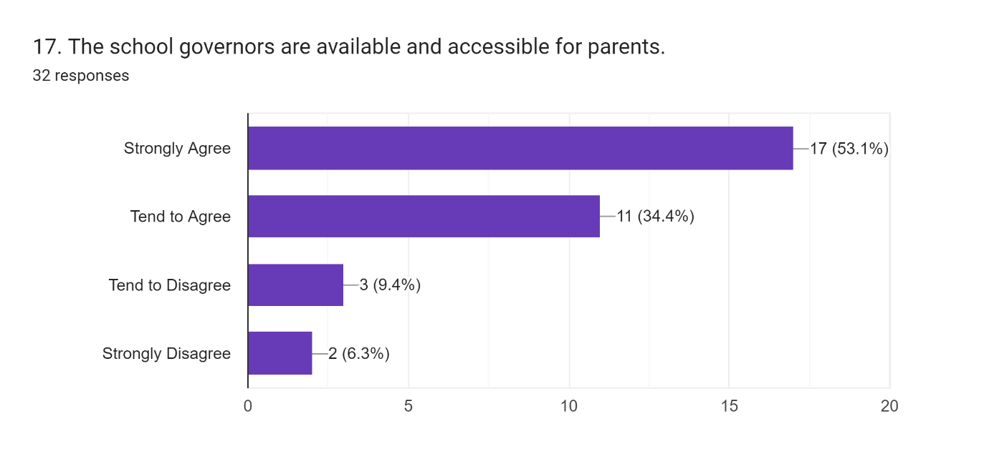 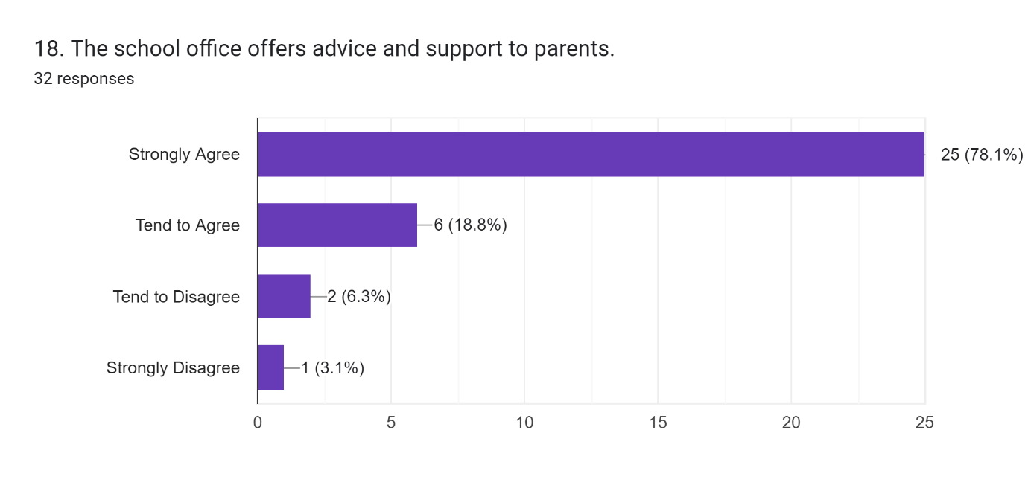 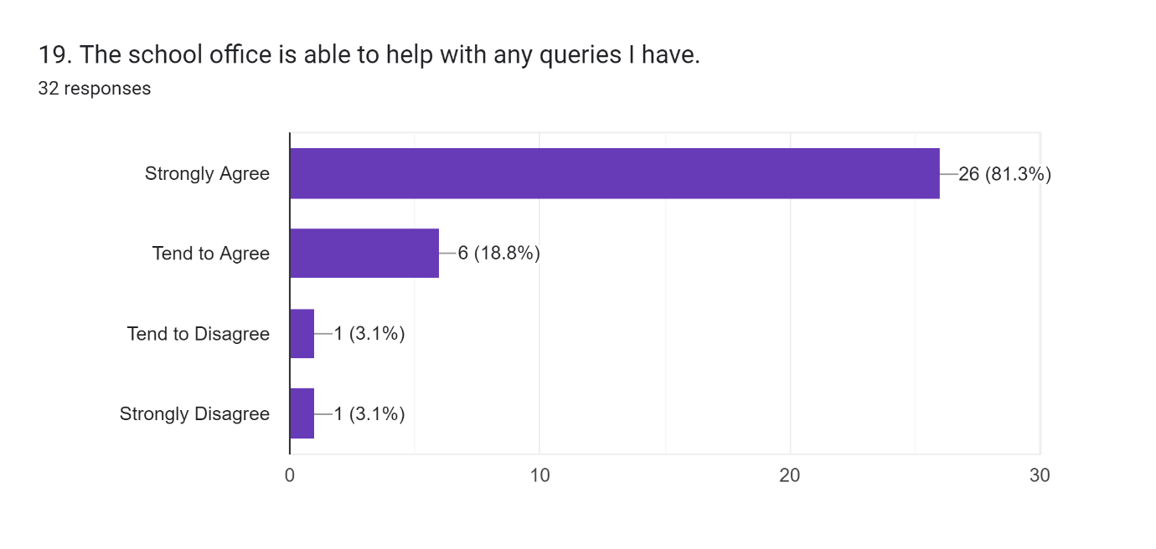 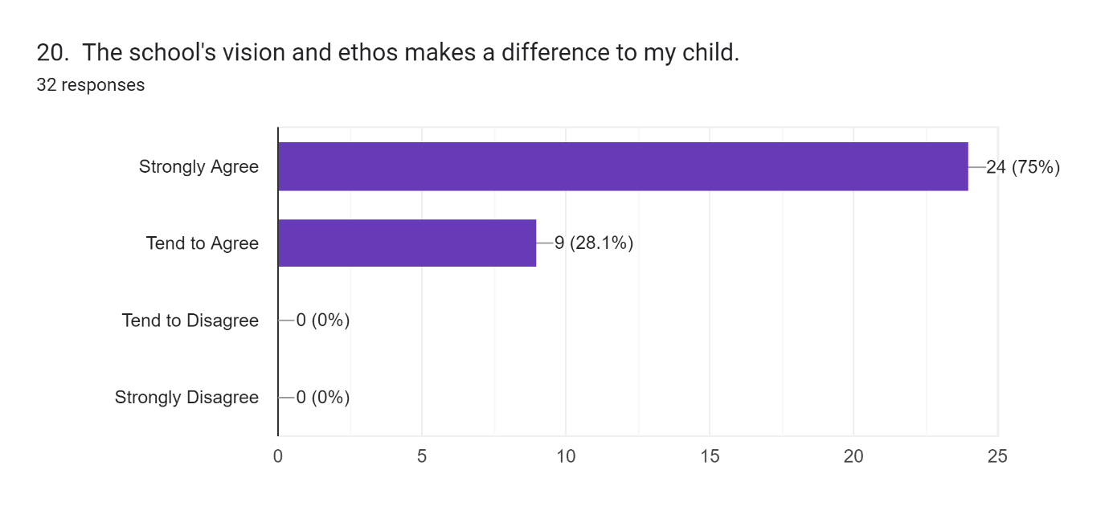 21. Please comment on anything that the school does particularly well:15 responses
Supporting the children and families
I genuinely believe the school in its current format would be rated as Outstanding. In all the years I’ve been associated with it, in my qualified opinion, it has never been better. The Head Of School is fantastic, as are the teaching and support staff and the Leadership model and structure provides support and guidance at all times.
Treating each and every child as an individual. Looking after the mental well-being of the children, as well as their academic ability.
The ‘one school’ family’ ethos is evident. Everyone looks out for each other that’s really special.
Ms Davy is an excellent head of school and goes the extra mile to help children. We were really pleased with her handling of recent social issues with a group of children and it has helped our child to feel more secure at school. We were also very happy with the way school has listened to parents with regards to children’s interests - chess club, maths club are new in the last year. It’s great to see these going on and they’re very much enjoyed.
Work as hard as they can with Sen children making sure they are safe
Provides good school dinners
Strong leadership. It feels like a family.
Great school community and inclusive of so many different children. Teachers give fantastic encouragement to my child.
Overall, the school is exceptional and I am extremely happy and impressed by all the work that the teachers do, and the incredible effort they put in. Children are empowered to think for themselves and learn responsibly.
The school and teaching staff are warm and encouraging to all children and parents and it is evident that this makes helps children feel seen and noticed which in turn helps them progress. They take a holistic approach to topics and make the learning engaging and relevant. Thank you all.
Warm,caring and approachable.always has the kids best interests at heart
Recognises all children’s abilities and their daily emotions. There is always a teacher on the gate welcoming everyone into school and they notice each and every one. Communication is excellent through dojo. My children are noticeably thriving both in education and their social outlooks.
After school clubs are great for providing a range of opportunities for the children. The headteacher is amazing, always helping and comes back to you so quickly. She works so hard. Communication on dojo helps to be a community. Mrs S' rewilding project is awesome.

22. Please comment on how the school could be improved:12 responses
Maybe an intercom at the main gate for after school club would help. Genuinely cannot think of anything else regarding teaching or communication.
Our kids have picked up some bad language recently. Would be good to curb that.
Would love to see more music happening - teaching children the skills to make music - eg instrumental teaching, recorder clubs
Maybe more 1 to 1 staff
School could be organised better, notices to parents and activities are always last minute. Activities are cancelled last minute and inviting families to events is last minute. Or being informed you child needs to be in PE kit or wellies once your child is already at a school. Parents evening changed to face face last minute so unable to attend. No input from teacher and accident forms can be 48hrs late. Admin staff can not answer a question without checking with head first. Teachers are always reporting that they are too busy to respond. Activties are never on first or last week of school, makes you feel the staff attitude to providing these is poor. No homework and when asked for explanation of home learning book, there is not one. Nothing is consistently followed through. Not great prep for secondary school.
More regular reporting on pupil progress.
To correct behaviour such as swearing from the same pupils. We do not use bad language at home and find it very difficult hearing my child repeat naughty words that they have picked up from her class. Sometimes I feel that there isn’t a lot of notice given when organising events. Maybe a two week notice would be more useful so parents can plan so we don’t miss out.
While being inclusive is great, it has brought an increase in disruptive and bad behaviour to the school which is a shame. Maybe a cap on how many children with issues should be looked at as it does impact the learning of other children.
As I have been discussing with the headteacher, I am keen for my child to be pushed as much as possible in maths, and for the teacher to aim to be more flexible about children, such as mine who claim to grasp the core concepts quickly and within like to be able to proceed with challenging work.
They need help with more funding and resources
It’s wonderful!
Some information gets lost on dojo and you can end up missing key information that impacts the child. The further up the school the kids go it feels like you know less about the curriculum and their grasp of it. It would be great if the after school clubs were a bit more accessible. More outdoor opportunities would be great.

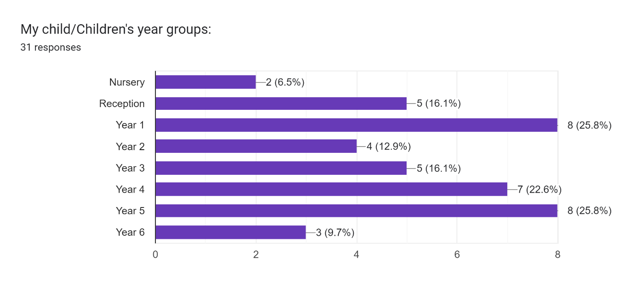
Thank you for taking the time to complete this questionnaire and share your feedback with us. Please add your name if you wish to:9 responses
Doug Honey
Laura
Mat Booth
Abigail Pahdi
Claire Pritchard
Martin Hampton
Rosie
Kaz white
Kelly Haggar

