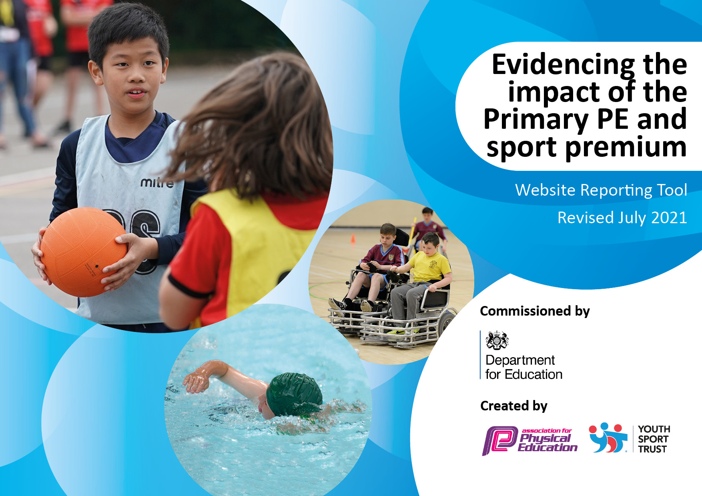
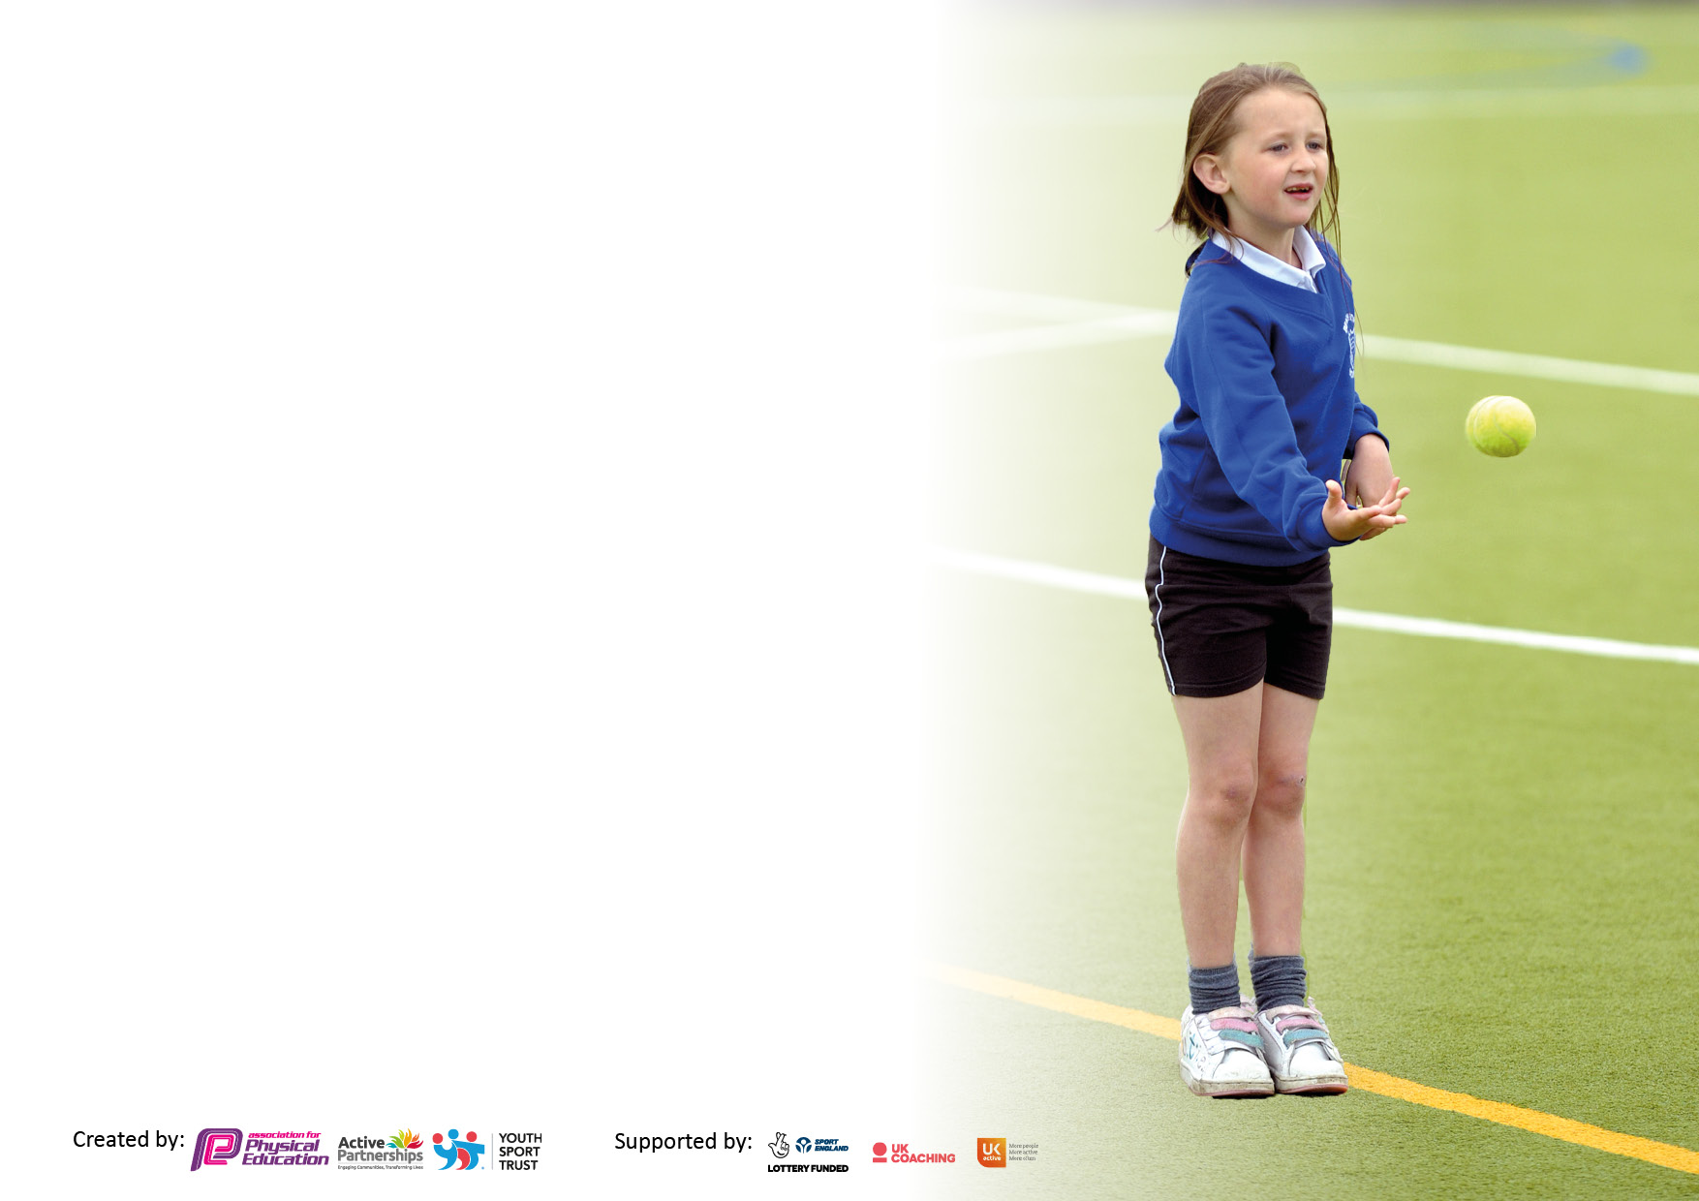

It is important that your grant is used effectively and based on school need. The Education Inspection Framework makes clear there will be a focus on ‘whether leaders and those responsible for governors all understand their respective roles and perform these in a way that enhances the effectiveness of the school’.

Under the Quality of Education Ofsted inspectors consider:
Intent - Curriculum design, coverage and appropriateness
Implementation - Curriculum delivery, Teaching (pedagogy) and Assessment
Impact - Attainment and progress

To assist schools with common transferable language this template has been developed to utilise the same three headings which should make your plans easily transferable between working documents.

Schools must use the funding to make additional and sustainable improvements to the quality of Physical Education, School Sport and Physical Activity (PESSPA) they offer. This means that you should use the Primary PE and sport premium to:

- Develop or add to the PESSPA activities that your school already offer
- Build capacity and capability within the school to ensure that improvements made now will benefit pupils joining the school in future years
- The Primary PE and sport premium should not be used to fund capital spend projects; the school’s budget should fund these.

Pleasevisitgov.ukfortherevisedDfEguidanceincludingthe5keyindicatorsacrosswhichschoolsshoulddemonstrate animprovement.Thisdocumentwillhelpyoutoreviewyourprovisionandtoreportyourspend.DfEencouragesschools to use this template as an effective way of meeting the reporting requirements of the Primary PE and sport premium.

We recommend you start by reflecting on the impact of current provision and reviewing the previous spend.

Schools are required to publish details of how they spend this funding, including any under-spend from 2019/2020, as well as on the impact it has on pupils’ PE and sport participation and attainment. All funding must be spent by 31st July 2022.

We recommend regularly updating the table and publishing it on your website throughout the year. This evidences your ongoing self-evaluation of how you are using the funding to secure maximum, sustainable impact. Final copy must be posted on your website by the end of the academic year and no later than the 31st July 2021. To see an example of how to complete the table please click HERE.

Details with regard to funding
Please complete the table below.

Total amount carried over from 2019/20 | £6638.50
Total amount allocated for 2020/21 | £23,438.50
How much (if any) do you intend to carry over from this total fund into 2021/22? | £0
Total amount allocated for 2021/22 | £16790
Total amount of funding for 2021/22. To be spent and reported on by 31st July 2022. | £18831
Swimming Data
Please report on your Swimming Data below.

Meeting national curriculum requirements for swimming and water safety.  N.B. Complete this section to your best ability. For example you might have practised safe self-rescue techniques on dry land which you can then transfer to the pool when school swimming restarts.  Due to exceptional circumstances priority should be given to ensuring that pupils can perform safe self rescue even if they do not fully meet the first two requirements of the NC programme of study | Figures based on the children’s previous data from lessons throughout their year 5 swimming lesson. Due to Covid-19 the year 6 summer swimming did not happen.
What percentage of your current Year 6 cohort swim competently, confidently and proficiently over a distance of at least 25 metres?  N.B. Even though your pupils may swim in another year please report on their attainment on leaving primary school at the end of the summer term 2020.  Please see note above | % 60
What percentage of your current Year 6 cohort use a range of strokes effectively [for example, front crawl, backstroke and breaststroke]?  Please see note above | % 60
What percentage of your current Year 6 cohort perform safe self-rescue in different water-based situations? | %80
Schools can choose to use the Primary PE and sport premium to provide additional provision for swimming but this must be for activity over and above the national curriculum requirements. Have you used it in this way? | Yes/No

Action Plan and Budget Tracking
Capture your intended annual spend against the 5 key indicators. Clarify the success criteria and evidence of impact that you intend to measure to evaluate for pupils today and for the future.

Academic Year: 2020/21 | Total fund allocated: | Date Updated:
Key indicator 1: The engagement of all pupils in regular physical activity – Chief Medical Officers guidelines recommend that primary school pupils undertake at least 30 minutes of physical activity a day in school |  |  |  | Percentage of total allocation:
 |  |  |  | >1%
Intent | Implementation |  | Impact
Your school focus should be clear what you want the pupils to know and be able to do and about  what they need to learn and to  consolidate through practice: | Make sure your actions to achieve are linked to your intentions: | Funding allocated: | Evidence of impact: what do pupils now know and what can they now do? What has changed? | Sustainability and suggested next steps:
Purchase of equipment specifically for children with SEND. | Trampette and gym balls have been purchased, providing regular physically active breaks. | £121 | High proportion of children with sensory needs use these at least 1x per day for a sensory break. | Ensure that these are available as and when children feel they’re needed.
Key indicator 2: The profile of PESSPA being raised across the school as a tool for whole school improvement |  |  |  | Percentage of total allocation:
 |  |  |  | 24%
Intent | Implementation |  | Impact
Your school focus should be clear what you want the pupils to know and be able to do and about  what they need to learn and to  consolidate through practice: | Make sure your actions to achieve are linked to your intentions: | Funding allocated: | Evidence of impact: what do pupils now know and what can they now do? What has changed?: | Sustainability and suggested next steps:
PE subject leader time to develop and deliver PE across the school.  Showcase the school’s PESSPA achievements. | To ensure that there is a broad and balanced curriculum in place throughout the school, curriculum maps are in place, assessment is implemented and policies are all updated.  Invest in a trophy cabinet to store awards and achievements. | £3250  £1284 | Children get access to a comprehensive, high quality PE programme across the school which raises their confidence, achievement and attainment in PE and wider curriculum.  Children are able to see the awards and sense of pride but also aspirations. | Due to sustainable plan, PE delivery continues to develop for the future.  Children to aim to be included within the achievements.

Key indicator 3: Increased confidence, knowledge and skills of all staff in teaching PE and sport |  |  |  | Percentage of total allocation:
 |  |  |  | 62%
Intent | Implementation |  | Impact
Your school focus should be clear | Make sure your actions to | Funding | Evidence of impact: what do | Sustainability and suggested
what you want the pupils to know | achieve are linked to your | allocated: | pupils now know and what | next steps:
and be able to do and about | intentions: |  | can they now do? What has
what they need to learn and to |  |  | changed?:
consolidate through practice:
Subject leader award training to be provided for curriculum lead.  Qualified teacher from outside agency to come in twice a week for 36 weeks to provide CPD opportunities for staff and after school curriculum.  Members of ARENA sports partnership.  Scheme to support the confidence and upskilling teaching staff. | Attendance at a four-day course to upskill PE leader.  Upskill staff’s skills across the curriculum – specifically gymnastics and dance.  Access to a range of CPD opportunities, PE conferences and webinars.  Easy to follow schemes of learning to support the delivery of the curriculum, particularly areas that teachers struggle with. | £0 – carried forward from previous year  £10,044  £450  £1350 | As a result of attending the course, subject leader will be qualified to lead PE and transfer knowledge and skills across the school.  Teachers and TAs reported that they are more confident in the delivery of the curriculum. Children more confident and attaining higher level within these areas.  80 children have had access to specialist teaching in these areas. 80 children have had access to specialist teaching in these areas.  Teachers have been given opportunities to attend conferences and webinar and been directed for CPD opportunities.  Teachers have become more confident at delivering the curriculum. | Training can be transferred and subject leader will have the knowledge to lead subject in the future.  Next Step: To continue to provide further training opportunities for the subject leader.  Staff can cascade knowledge to other staff members and deliver content in the future.  Teachers and TAs have become more confident in the delivery of these areas.  Ensure consistency in use of scheme.
Key indicator 4: Broader experience of a range of sports and activities offered to all pupils |  |  |  | Percentage of total allocation:
 |  |  |  | 5%
Intent | Implementation |  | Impact
Your school focus should be clear | Make sure your actions to | Funding | Evidence of impact: what do | Sustainability and suggested
what you want the pupils to know | achieve are linked to your | allocated: | pupils now know and what | next steps:
and be able to do and about | intentions: |  | can they now do? What has
what they need to learn and to |  |  | changed?:
consolidate through practice:
Additional achievements:  Purchase of extra equipment.  Alternative Sports Day delivered by arena for all pupils in the school.  Swimming booster for Year 6 children. | Purchase of new equipment will allow the children to access a wider range of sports and activities.  Alternative Sports day implemented within school.  Children attended 5 x 1 hour sessions with the younger years to boost confidence and competence. | £320.14  £320  £45 | Equipment have allowed the staff to carry out a wider range of PE provision and give children access to a range of sports.  Children have been provided the opportunity to try a wider range of different sports. This will allow them different opportunities and enthused children to try these sports on a regular basis.  Children gained more confidence in the water and made great progress with their swimming. 1 child is now close to confidently swimming 25m. | Sustainability: Equipment will be used for the foreseeable future to deliver high quality PE.  Next steps: To continue to offer a range of PE and sporting activities for all children.  Look at investing in equipment for some of these sports and add it to our curriculum/after-school club provision.

Key indicator 5: Increased participation in competitive sport |  |  |  | Percentage of total allocation:
 |  |  |  | %8
Intent | Implementation |  | Impact
Your school focus should be clear | Make sure your actions to | Funding | Evidence of impact: what do | Sustainability and suggested
what you want the pupils to know | achieve are linked to your | allocated: | pupils now know and what | next steps:
and be able to do and about | intentions: |  | can they now do? What has
what they need to learn and to |  |  | changed?:
consolidate through practice:
Membership to OCRA for competitions and events.  ANDARAS MAT competitions include with ARENA membership.  Raise Sports Day competition. | To provide children with a range of competitive events for all children to lead to the Devon games.  To provide children with a range of competitive events against other MAT schools.  Invest in individual trophies to generate more competition. | £1600  Costed as part of ARENA membership.  £42 | 100% of children have participated in in-school competitions with 30% pupils involved in competition outside of school.  All children were more competitive and willing to participate in more events. | To provide more opportunity for KS1 children to participate in out-of-school competition and a wider range of sporting competitions.  Purchase a team house trophy and display the trophies with the children’s names by them.

Signed off by
Head Teacher: | L.Davy
Date: | 26.07.2022
Subject Leader: | D.Payton
Date: | 25.07.2022
Governor: | R.Wilson
Date: | 29.07.2022

