Long Term planning
School: Lew Trenchard
Completed by: L. Broadbridge
Date: Sept 2025/2026
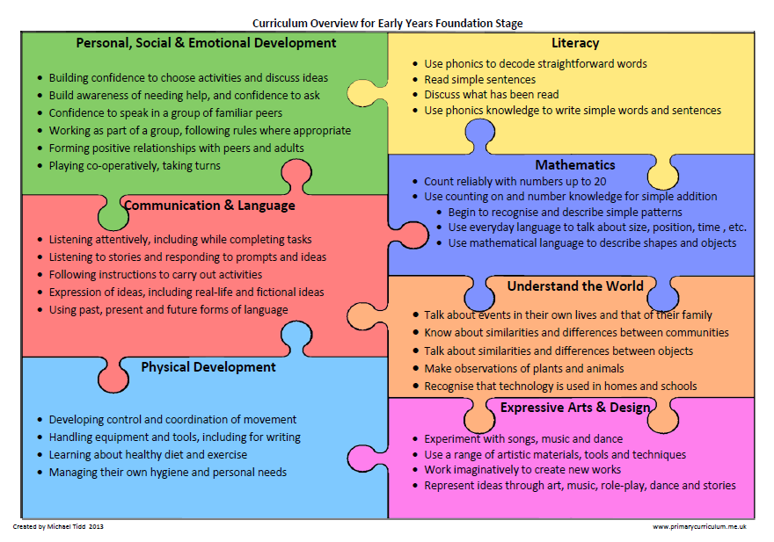
Name/ Signature/ Date:
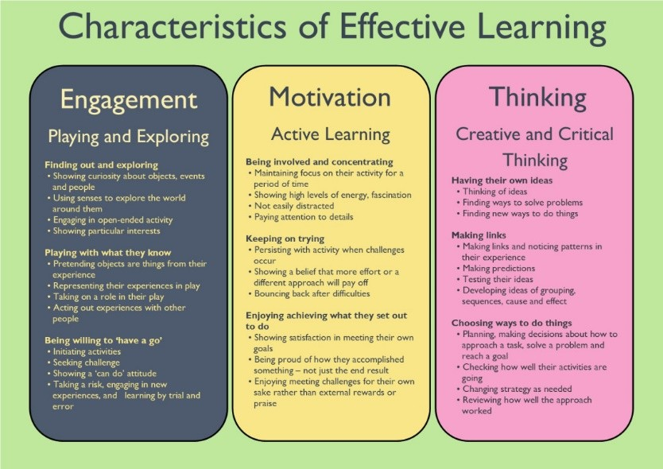

Overarching Principles
Unique Child: Every child is unique and has the potential to be resilient, capable, confident and self-assured.
Positive Relationships: Children flourish with warm, strong & positive partnerships between all staff and parents/carers. This promotes independence across the EYFS curriculum. Children and practitioners are NOT alone – embrace each community.
Enabling environments: Children learn and develop well in safe and secure environments where routines are established and where adults respond to their individual needs and passions and help them to build upon their learning over time. Children benefit from a strong partnership between practitioners and parents and/or carers.
Learning and Development: Children develop and learn at different rates. We must be aware of children who need greater support than others.

Lew Trenchard Preschool/Reception Long Term Overview
 | Autumn |  |  | Spring |  |  |  | Summer
Possible Themes/Interests/  Lines of Enquiry  Based on children’s interests so may change throughout the year | My family | Themes |  | Themes |  | Animals |  | Themes |  |  | What happens in Summer?
 | Who lives with me?  All about me  Change of Season | Fireworks  Seasons  Space  Christmas |  | Chinese New Year  Easter  Mother’s Day |  | Mini beasts  Farm animals  Pets |  | Seasons  Father’s Day |  |  | Beach  Holidays  Weather
Key Texts/core books | You choose | Stick man  Christmas surprise  Spaceman, spaceman |  | Chick and Bunny’s adventure  Mommy and me |  | Brown Bear, Brown Bear  We’re Going on a Lion Hunt  On the Farm  The Hungry Caterpillar  Dear Zoo |  | Sunflowers yellow  Daddy, Daddy |  |  | Tiddlier  Spot goes on holiday  Sharing a shell
Communication and Language | .
2-3 years  Listening, Attention, and Understanding  Speaking | Singing,rhymes, music and toys that make sounds  Developing use of language during play/adult modelling. | Introducing rhythmic patterns in rhymes and stories |  | Start to express feelings, using appropriate words.  Beginning to ask simple questions |  | Start to develop conversation, often jumping from topic to topic. Confidently put 2/3 words together.  Identifies action words by following simple instructions e.g. who is jumping? |  | Begin to understand more complex sentences  Listen to simple stories and understand what is happening, with the help of the pictures. |  |  | Use language to share feelings, experiences and thoughts.  Understanding the use of objects. – what do we use to cut
3-4+ years  Listening, Attention, and Understanding  Speaking | Listening to stories and begin to recall information  Developing listening skills | Sing Songs and Talk about familiar stories |  | Developing vocabulary  Asking and answering questions |  | Asking and answering questions  Developing sentence length |  | Express a point of view  Use talk to organise ideas and play |  |  | Confident in listening to others and responding  Developing speaking audibly
Registration and Circle times | Develop speaking and listening skills, interactions, following instructions, explaining ideas, thoughts and feelings.  Following routine, using repetition with songs, eg; days of the weeks song/months of the year song. Sound and number of the week, nursery rhyme of the week and show and tell.
Daily routines | Practice using new vocabulary, develop social phrases, engage in communication with friends and adults, sing songs, sign, explain ideas and  thoughts, engage in and talk about books, retell stories and create their own.
Busy Learning | Learn new vocabulary, engage in singing or talk about the world around them. Learn rhymes and songs. Mark making and turn taking.
 | Classroom enhancements
 | Home corner role play area | props for relating to real life experiences |  | Grow cress seeds int the classroom |  | Green grocers role play/fruit depending on season |  | Vocabulary extension words |  |  | Painting shells/stones from the beach
PSED
2-3 years  Self-Regulation  Managing Self  Building Relationships | Finding ways of managing transitions, for example from their parent to their key person  Interested in their own and others physical characteristics e.g. pointing to features | Play with increasing confidence on their own and with other children, because they know their key person is nearby and available  Beginning to express preferences and decisions. |  | Experiments with what their body can do by setting themselves physical challenges  Developing an understanding/interest in differences e.g. in gender, ethnicity and ability |  | Begin to show ‘effortful control’. For example, waiting for a turn and resisting the strong impulse to grab what they want or push their way to the front  Begin to use ‘you, me and I’ in talk |  | Show empathy and concern for people who are special to them  Knows their own name, their preferences and interests, becoming aware of unique abilities |  |  | Seeks out others to share experiences  Beginning to be able to cooperate in favourable situations
3-4+ years  Self-Regulation  Managing Self  Building Relationships | Talk about feelings e.g. happy and sad  Identify feelings in others  Select and use resources | Develop a sense of community and responsibility  Show increasing confidence in social situations |  | Developing ways to solve conflicts  Shows understanding of rules and why they are important |  | Develop ways of being assertive  Develop independence in managing own care needs |  | Develop play with others  Show increasing confidence in social situations |  |  | Demonstrate developing confidence in new situations  Independent dressing and self-care  making healthy choices
Registration and Circle times | Develop speaking and listening skills, self-esteem, a sense of community, understanding of how their behaviour affects others, problem-solving, a sense of responsibility and improved relationships between children, and between children and their teacher.
Daily routines | Self-registration, song and story-time, lunch choosing, book voting, tidy-up time, washing hands independently, change into wet weather gear, use toilets with support, snack time (free-flow during busy learning), lunchtimes, getting ready for home, follow the class rules/charter, to be ready, safe and respectful
Busy learning | Build relationships with others, see themselves as a valued individual, set simple challenges, show resilience and perseverance, manage feelings and behaviour appropriately, play co-operatively, take turns and share, show sensitivity to others
Gross Motor Skills | Develop movement skills- gross motor, body control and strength.  Gross Motor Skills:  - Climbing on various equipment  - Craw, walk, run, jump, matching skill to task  - Use large muscle movements to wave flags and streamers  - Kick, throw and catch a ball  - Clap and stamp to music  - Dance and hold a pose  - Paint and make marks  - To be able to begin to sit on a push-along wheeled toy (2-3 years)  - Riding tricycles (3-4 years)  - Going up and down stairs  - Carrying heavy items  - Washing windows and toys  - Building with large construction
Fine Motor Skills | Develop fine motor skills- scissor skills, cutlery, preference for a dominant hand  Fine Motor Skills:  - Use tools and equipment like spades, spoon and fork, water jugs, scissor scoops, tweezers, large pipettes  - Funky finger activities  - Play-dough (dough disco)  - Tearing Paper  - Scissors- sniping paper progressing to moving forwards  - Mark making using a variety of tools and media  - Use of Clips, Clasps, zips, buttons, screwing Jars and nuts and bolts  - Finger Puppets
Literacy | We aim to become a ‘Book Worm’ enthusiast, readily accessing them for pleasure, turning pages individually, describing characters, scenes and outcomes in illustrations and recognising some symbols and letters of personal interest in their environment including digital material.  And a Phase 1 ‘Superhero Listener’ with radar hearing, discerning, remembering, sequencing and creating dynamic sounds in everyday play, with awesome rhyme awareness and ability to segment and blend orally.
2-3 years  Word Reading  Writing  Comprehension | Getting to know routines Letters and sounds phase 1
2-3 years  Word Reading  Writing  Comprehension | Enjoys songs and rhymes tuning in and paying attention  Copy finger movements and other gestures  Pay attention and responds to the pictures or the words in books  Enjoy making marks freely |  | Enjoys sharing books with an adult  Enjoys rhythmic and musical activity with percussion, songs, clapping along with the beat  Enjoys listening or joining in with words of familiar songs and nursery rhymes  Pay attention and responds to the pictures or the words in books  Enjoys making marks freely |  | Has favourite books and seeks them out, to share with an adult  Repeat words and phrases from familiar stories  Join in with songs and rhymes, copying sounds, rhythms, tunes and tempo. (Begin to engage in phase 1 phonic activities)  Enjoys mark making on paper, on screen and on different textures, such as in sand or playdough and through using touch-screen technology | Ask questions about the book. Makes comments and shares their own ideas  Join in with songs and rhymes, copying sounds, such as loud, quiet, fast, slow, using instruments  Sing songs and say rhymes independently, for example, singing whilst playing.  Add some marks to their drawings, which they give meaning to. For example: “That says mummy.” | Develop play around favourite stories using props  Beginning to join in with conversations about stories and learn new vocabulary |  | Have favourite books and seeks them out, to share with an adult, with another child, or to look at alone  Notice some print, such as the first letter of their name, a bus or door number, or a familiar logo.  (Recognises important prints to me)  Sing songs and say rhymes independently, for example, singing whilst playing  Repeat words and phrases from familiar stories  To begin to make marks independently.
3-4+ years  Word Reading  Writing  Comprehension | Letter and sounds phase 1 RWI (summer term)
3-4+ years  Word Reading  Writing  Comprehension | Enjoys making marks independently  Joins in with a range of Nursery Rhymes, jingles and songs  To be able to enjoy stories with adults, sometimes in a small group  To begin to develop play around favourite stories using props  Discriminates between different sounds. (Environmental and instrumental sounds)  Talks about pictures in books | Begin to develop phonological awareness.  Begin to count or clap syllables  Develop use of some story language  Learns new vocabulary from texts and topics  Develop understanding of concepts e.g. same/different  Join in with Dough Disco sessions |  | Develop language of direction (up down, round, and back)  Can access a wide range of mark making materials in class and in the outdoor provision  Makes marks using a range of materials  Imitate writing in play situations e.g. shopping lists, parking tickets |  | Talks about the different parts of a book  Discriminates between different sounds (animal)  Recognises rhyming words in games, stories and poems.  Recognises familiar logos and labels in the environment  To know that text has meaning.  Builds an understanding that text is read from right to left |  | Develops Understanding of the five key concepts about print:  - print has meaning  -Page sequencing  - print can have different purposes  - we read English text from left to right and from top to bottom  - the names of the different parts of a book  Makes predictions about stories  Can re-tell familiar stories using a story map  Talks about different parts of a story. (Beginning, middle, end)  Demonstrates an understanding of what has been read to them by retelling stories and narratives using their own words and recently introduced vocabulary  Begin to recognise  Name |  | Joins with oral blending and segmenting games.  Begins to blend and segment CVC words  Joins in with shared writing experiences and contributes ideas  Recognises rhymes and alliteration  Recognises initial sounds in words  Joins in with weekly RWI phonic lessons introducing 1 sound per week.  Recognises name  Write some or all of my name  Write some letters accurately
2-3 years  Number  Numerical Pattern  Shape and Space | Maths: Noticing number  React to changes of amount in a group of up to three items  Say some number names randomly  Take part in finger rhymes/counting rhymes | Maths: Comparing and combing objects  Compare saying lots, more, the same  Combine objects like stacking blocks and cups. Put objects inside others and take them out again  Beginning to recite some number names in sequence  Build with a range of resources |  | Maths: Counting skills and categorising  Count in everyday contexts, sometimes skipping numbers - ‘1-2-3-5.’  Recites some number names in sequence  Beginning to categorise objects according to properties such as shape or size |  | Maths: Developing understanding of language  Compare saying bigger, smaller, high, low, tall, heavy  Developing understanding of positional language  Recites numbers in sequence 1-5 | Maths: Counting skills  Say one number for each item in order: 1,2,3 (maybe more)  Recites numbers past five sometimes in sequence  Recognise some numerals of personal significance  Selects a small number of objects from a group when asked |  | Maths: Shape exploration, measure & pattern  Counting to 5/10  Make simple comparisons between objects relating to size, length, weight and capacity  Exploring shapes in play  Notices simple patterns and arrange things in patterns
3-4+ years  Number  Numerical Pattern  Shape and Space | Maths: Counting skills  Using number language in play  Counting to 5/10  Counting out objects 1-1  Select shapes appropriately e.g. flat surfaces for building, a triangular prism for a roof etc.  Talk about and identify the patterns around them. For example: stripes on clothes, designs on rugs and wallpaper, using informal language like ‘pointy’, ‘spotty’, ‘blobs’ etc. | Maths: Counting skills and shapes  Counting to 5/10  Counting out objects 1-1  Knows last number reached is the total (cardinal principle)  Exploring shapes in play and beginning to name them.  Showing number on fingers |  | Maths: Shape exploration and number recognition  Compare objects and amounts  Shape and number recognition  Recognising amounts and groups of objects to 3 without counting (subitising)  Using prepositions in their play and games  Talk about routes and locations |  | Maths: Patterns, number and Numicon  Number recognition.  Link numbers to amounts  Counting amounts to go with numbers.  Ordering  Notices shapes and combining shapes to make pictures or patterns. |  | Maths: Number recognition and measuring  Compare saying ‘more than’, ‘fewer than’  Exploring measures  Heavy/ light  Number recognition  Finds one more or less with objects  Starting to describe shape  Exploring and making patterns. |  |  | Maths: Measures, more and less  Realises that not just objects can be counted  Can count irregular arrangements to 10  Beginning to talk about shapes in everyday objects  Say a number one more than the given number to 5  Creates patterns, notices & correct an error
2-3 years  People, culture, and Communities  Past and Present  The Natural World | Shows interests in photographs of themselves and other familiar people and objects  Learns they have similarities and differences which connect them to and distinguish them from others  Repeat actions that have an effect (exploring how things work)  Beginning to explore natural materials, indoors and outside.  (curiosity, loose parts natural thinkers) | Demonstrates curiosity about people and shows interest in stories about people, animals or objects.  Explore and respond to different natural phenomena e.g. standing in the rain with wellies and umbrellas, crunching in frost, searching for bug etc. |  | Notice differences between people. (culture wheels, family days/ photos)  Enjoys playing with small world reconstructions building on their own experiences e.g. visiting farms, train track, beach, park etc.  Talk about their own experiences |  | Can talk about their immediate family, relation and pets  Talks about some of the things they’ve observed such as plants, animals, natural and found objects  Explore collections of materials with similar and/or different properties. |  | Remembers a special event and shows interest in the lives of people who are special to them  Beginning to use all their senses in hands-on exploration of natural materials (curious to explore and make own choices)  Beginning to make comments about plants, seeds and caring for growing plants. |  |  | Make connections between the features of their family and other families  Notice differences between people  Notices detailed features of objects in their environment  Explore and respond to different natural phenomena in their setting and on trips
3-4+ years  People, culture, and Communities  Past and Present  The Natural World | Begin to make sense of their own life story  Notices differences and connections in people and families  Show interest in different occupations  Explore materials with different properties | Begin to make sense of their own life-story and family’s history  Develop positive attitudes to people and their differences  In pretend play imitates events from own family or cultural background  Talk about the differences between materials and changes they notice. (Snow, Ice melting) |  | Talk about why things happen and how things work using a wide vocabulary  Explore collections of materials, talk about their observations  Knows there are different places and countries in the world  Explore and talk about different forces |  | Begin to understand the need to respect and care for the natural environment and all living things  Use all their senses in hands on exploration  Know that animals live in different parts of the world |  | Continue developing positive attitudes about the differences between people  Understand the need to care for and respect the environment for example, plant seeds and care for plants  Understand the key features of the life cycle of a plant and animal  Begins to notice changes in things e.g. when bananas turn black when they stay in the bowl for too long or the shoots growing from a seed |  |  | Understand that their friends might do things differently to them e.g. eating different foods at home or celebrating events with their families at different times  Knows that there are different countries in the world and talks about the differences they have experienced or seen in photos  Talk about different environments and the animals and plants which live and grow there
Technology  2-3 years | Toys with buttons, flaps and simple mechanisms, beginning to learn to operate them. |  |  | Mechanical toys, e.g., turns the knob on a wind-up toy or pulls back on a friction car. |  |  |  | Plays with water to investigate ‘low technology’ such as washing and cleaning.  Uses pipes, funnels and other tools to carry and transport water from one place to another
Technology  3-4+ years | Knows how to operate simple equipment, e.g.  turns on CD player, uses a remote control, can  navigate touch-capable technology with support |  |  | Toys with knobs or pulleys, or real objects such as cameras or mobile phones.  To be able to begin to acquire basic skills in turning on and operating some ICT equipment |  |  |  | Age-appropriate apps on the Interactive WB and iPad.
2-3 years  Creating with materials  Being Imaginative | Explore paint, using fingers and other parts of their bodies as well as brushes and other tools | Notices and becomes interested in the transformative effect of their actions on materials and resources |  | Manipulate and play with different materials using various tools like scissors, cutters, hammers. |  | Make simple models which express their ideas.  Makes marks intentionally. (in flour, sand, pens, crayons, paint etc.) |  | Explore different materials, using all their senses to investigate them.  Build simple models or structures |  |  | Start to develop pretend play  Enjoys and responds to playing with colour in a variety of ways
3-4+ years  Creating with materials  Being Imaginative | Colour awareness and mixing  Make simple models which express their ideas | Listen to sounds with increasing attention  Join different materials and explore different textures  Develop pretend play |  | Develop small world imaginative play  Create closed shapes with continuous lines, and begin to use these shapes to represent objects |  | Develop stories using small world equipment like animal sets, dolls and dolls houses etc  Develop pretend play with others  Use available resources as props |  | Begin to make imaginative and complex ‘small worlds’ with blocks and construction kits, such as a city with different buildings and a park.  Explore colour and how colour can be changed |  |  | Develop pencil and tool control to create complex and detailed pictures.  Safely use and explore lots of different tools such as hammers, scissors, hole punches and saws  Makes up stories when playing  Draws for a purpose
2-3 years | Explore their voices and enjoy making sounds.  Move and dance to music | Show attention to sounds and music (when you play different cultural/genre/tempo music etc.) |  | Explore their voices and enjoy making sounds. (loud, quiet, fast, slow) |  | Join in with songs and rhymes, making some sounds. |  | Explore a range of sound-makers and instruments and play them in different ways. |  |  | Make rhythmical and repetitive sounds.  Enjoy and take part in action songs
3-4+ years | Creates sounds by rubbing, shaking, tapping, striking or blowing | Experiments with ways of playing sound makers e.g. fast/slow, loud/quiet |  | Remember and sing entire songs  Pitch match songs  To know and identify percussion instruments e.g., drums, woodblocks, triangles, bells. |  | Plays instruments with increasing control to express feelings and ideas  Move in a range of ways |  | Create their own songs and rhythms  Join in with simple songs from around the world. |  |  | Sings familiar songs e.g. pop songs, TV shows, rhymes, songs from home

